# Iteration Report

This report covers step one and two of the refactoring process. Although testing already exists coverage is not nearly close to 100%. The purpose of this iteration is to expand on the current tests to create 100% coverage.

## Tasks Completed

1. Renamed “UnitTestsKris.py” to unittests.py to avoid confusion.
2. “Dead Code” Removed from graph.py, the set_data(self, new_graph) on line 182
3. Installed testfixtures package to use in unittests.py
4. Removed unused exceptions such as..

*# Raises exception if the incorrect amount of args have been entered***if** len(argss) > 2 **or** len(argss) < 2:  
 **raise** TypeError

In graph.py at line 65 (of original code), this would never be raised as the interpreter already raises this exception should the user input to many parameters.

1. Imported the shultil library to unittests.py
2. Removed valid method **def** valid_date(self, birthday): from line 50 of file_handler.py (in original files). Firstly, it seems to be dead code, secondly it does not work anyway.
3. Also removed the method that followed the previously mentioned method, valid_age(self, date) from file_handler.py for the same reasons.
4. Import io to unittests.py, used to test output strings
5. Changed data validation length of employee number from **r'[a-z][0-9]{3}'** to **r'[a-z][0-9]{2}'** on line 72 of filemanagement/filehandler.pyto match format used
6. Changed **if** re.match(**r'[0-9]{3}'**, person[3]): to **if** re.match(**r'^[0-9]{2,3}$'**, person[3]): on line 111 of filehandler.py to accommodate salaries less than $100,00
7. Changed pointless **elif** len(args) == 2: to simple else in line 36 of interpreter.py

## Coverage Output Original

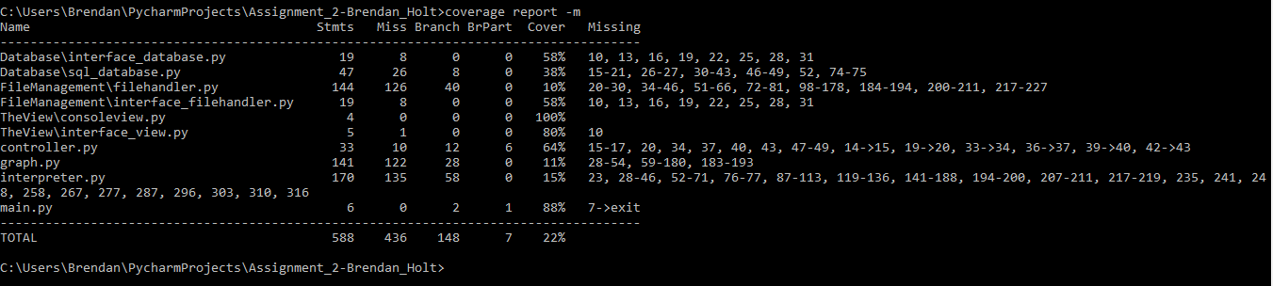

## Coverage Output After

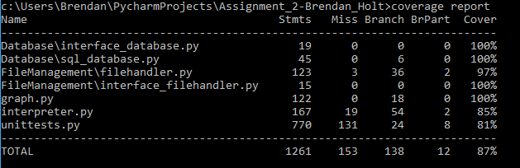

## Problems

1. Was not able to get mock working to test input
2. Some coverage not complete such as unittests.py due to error checking creating branches that are covered unless an exception that is beyond ordinary is raised.
3. Was not able to get %100 coverage on the filehandler due to being unable to test if a number is a double.

## Coverage commands used

coverage run --branch --omit=C:\Users\Brendan\AppData\Roaming\Python\Python34\site-packages\testfixtures\*.py unittests.py -b

coverage report

coverage html

*note the omit used to ensure files not contained in the testfixtures library that was used to test the raising of exceptions. The path will vary depending on computer.